USK VALLEY WORKING GUNDOG CLUB
(ID No 718)

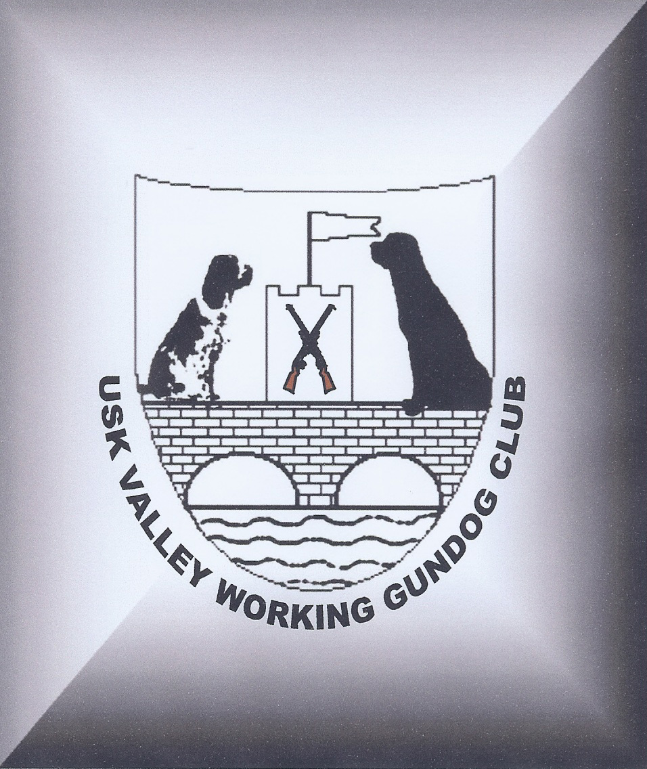

FIELD TRIAL JUDGES SEMINAR & EXAM FOR RETRIEVERS

Delivered by an Accredited Kennel Club Presenter

on
Sunday 8th May 2016

Venue: Little Mill Village Hall, Berthon Road, Little Mill, Pontypool NP4 0HE
Arrive at 10.30am for an 11am start

£25.00 for members
£35.00 for non-members

Price includes refreshments, a light lunch, Kennel Club J Regulation Booklet and briefing notes (Exam is optional)

Pre-registration is requlred for this event due to limited spaces available
Please contact Jill Bowler on Tel 01291 650206 or email jillbowler@hotmail.com

Payment will be required in advance to secure your placement
Please complete the attached registration form and send along with your payment by Wednesday 27th April 2016 to Mrs Jill Bowler, Ty Bach, Llangwm, Usk, Monmouthsire, NP15 1HG
Please make cheques payable to Usk Valley Working Gundog Club

USK VALLEY WORKING GUNDOG CLUB
(ID No 718)

FIELD TRIAL JUDGES SEMINAR & EXAM FOR RETRIEVERS

Delivered by an Accredited Kennel Club Presenter

on
Sunday 8th May 2016

Venue: Little Mill Village Hall, Berthon Road, Little Mill, Pontypool NP4 0HE
Arrive at 10.30am for an 11am start

NAME OF DELEGATE:

ADDRESS:

TELEPHONE NUMBER:

EMAIL ADDRESS:

Please find enclosed payment of £ to confirm my placement on the above mentioned seminar.

I confirm I would / would not* like to sit the end exam
*please delete as appropriate

